import streamlit as st
from datetime import datetime import pandas as pd
import io import re

# Optional OCR dependencies try:
from PIL import Image import pytesseract OCR_AVAILABLE = True
except Exception:
OCR_AVAILABLE = False

import plotly.express as px
st.set_page_config(page_title="Finance Tracker", layout="centered") #
# Helpers #
def init_state():
if "users" not in st.session_state:
st.session_state.users = {} # username -> {password: "..."} if "current_user" not in st.session_state:
st.session_state.current_user = None if "transactions" not in st.session_state:
st.session_state.transactions = {} # username -> list of txns

def save_transaction_for_user(user, txns): st.session_state.transactions[user] = txns

def load_transactions_for_user(user):
return st.session_state.transactions.get(user, [])

def extract_amount_from_text(text: str): """

Similar heuristics to your JS function:
- normalize Rs/INR to ₹
- search lines for keywords and amounts
- fallback: check last few lines
- return largest sensible candidate or None """
if not text: return None
# Normalize
text = re.sub(r"Rs\.?", "₹", text, flags=re.I) text = re.sub(r"INR", "₹", text, flags=re.I) # remove weird ascii
text = re.sub(r"[^\x00-\x7F₹\d,.\nA-Za-z ]+", " ", text) lines = [l.strip() for l in text.splitlines() if l.strip()] keywords =
re.compile(r"(total|amount|grand|net|payable|paid|balance|due|bill|final|cash|credit)", re.I) amount_re = re.compile(r"₹?\s?(\d{1,3}(?:[,\d]{0,})?(?:\.\d{1,2})?|\d+(?:\.\d{1,2})?)") candidates = []
for ln in lines:
if keywords.search(ln):
for m in amount_re.finditer(ln): s = m.group(1).replace(",", "") try:
v = float(s)
if 10 < v < 10_000_000:
candidates.append(v) except:
pass
if not candidates: tail = lines[-6:] for ln in tail:
for m in amount_re.finditer(ln): s = m.group(1).replace(",", "") try:
v = float(s)
if 10 < v < 10_000_000:
candidates.append(v) except:
pass

return max(candidates) if candidates else None

#
# Authentication UI #
init_state()
st.title("💰 Personal Finance Tracker (Streamlit)") col1, col2 = st.columns([3,1])
with col1:
if st.session_state.current_user:
st.markdown(f"*Hello, {st.session_state.current_user}*") with col2:
if st.session_state.current_user: if st.button("Logout"):
# persist is session-only; clear current user st.session_state.current_user = None

if not st.session_state.current_user:
with st.expander("🔐 Login / Signup", expanded=True): tabs = st.tabs(["Login", "Signup"])
with tabs[0]:
u = st.text_input("Username (login)", key="login_user")
p = st.text_input("Password", type="password", key="login_pass") if st.button("Login", key="btn_login"):
users = st.session_state.users if not u or not p:
st.warning("Enter username & password") elif u not in users or users[u]["password"] != p:
st.error("Invalid credentials") else:
st.session_state.current_user = u st.success(f"Logged in as {u}") st.experimental_rerun()
with tabs[1]:
u2 = st.text_input("Choose username", key="signup_user")
p2 = st.text_input("Choose password", type="password", key="signup_pass") if st.button("Create Account", key="btn_signup"):

if not u2 or not p2:
st.warning("Enter username & password") elif u2 in st.session_state.users:
st.error("Username already exists") else:
st.session_state.users[u2] = {"password": p2} st.session_state.transactions[u2] = [] st.session_state.current_user = u2 st.success(f"Account created and logged in as {u2}") st.experimental_rerun()
st.stop()

# From here on user is logged in user = st.session_state.current_user
transactions = load_transactions_for_user(user)

st.markdown("---") st.header("Dashboard")

df_tx = pd.DataFrame(transactions) if transactions else pd.DataFrame(columns=["date","desc","type","amount"])
income = df_tx.loc[df_tx.type=="income","amount"].sum() if not df_tx.empty else 0.0 expense = df_tx.loc[df_tx.type=="expense","amount"].sum() if not df_tx.empty else 0.0 balance = income - expense

c1, c2, c3 = st.columns(3)
c1.metric("Income", f"₹{income:,.2f}")
c2.metric("Expenses", f"₹{expense:,.2f}")
c3.metric("Balance", f"₹{balance:,.2f}")
st.markdown("---") # Add transaction
st.subheader("➕ Add Transaction")
with st.form("add_txn", clear_on_submit=True): desc = st.text_input("Description")
amt = st.number_input("Amount (₹)", min_value=0.0, format="%.2f")
ttype = st.selectbox("Type", ["income","expense"]) submitted = st.form_submit_button("Add")

if submitted:
if not desc or amt <= 0:
st.error("Provide a description and positive amount.") else:
tx = {"date": datetime.now().strftime("%Y-%m-%d"), "desc": desc, "type": ttype, "amount": float(amt)}
transactions.append(tx) save_transaction_for_user(user, transactions) st.success("Transaction added") st.experimental_rerun()

# Transaction table + edit/delete st.subheader("📑 Transactions") if transactions:
df_display = pd.DataFrame(transactions) df_display.index = df_display.index.astype(int) st.dataframe(df_display, use_container_width=True)

cols = st.columns([1,1,1]) if st.button("Export CSV"):
to_download = pd.DataFrame(transactions) buf = io.StringIO() to_download.to_csv(buf, index=False)
st.download_button("Download CSV", buf.getvalue(), file_name=f"{user}_transactions.csv", mime="text/csv")

# Delete by index
idx_to_delete = st.number_input("Delete transaction index (row #)", min_value=0, max_value=len(transactions)-1, step=1, value=0, key="del_idx")
if st.button("Delete selected"): transactions.pop(idx_to_delete) save_transaction_for_user(user, transactions) st.success("Deleted") st.experimental_rerun()
idx_to_edit = st.number_input("Edit transaction index (row #)", min_value=0, max_value=len(transactions)-1, step=1, value=0, key="edit_idx")
if st.button("Load for edit"):
t = transactions[idx_to_edit] st.session_state.edit_desc = t["desc"]

st.session_state.edit_amount = t["amount"] st.session_state.edit_type = t["type"] st.session_state.edit_index = idx_to_edit st.experimental_rerun()
if "edit_index" in st.session_state: st.markdown("### Editing")
new_desc = st.text_input("Description (edit)", value=st.session_state.get("edit_desc",""))
new_amt = st.number_input("Amount (edit)", value=float(st.session_state.get("edit_amount",0.0)))
new_type = st.selectbox("Type (edit)", ["income","expense"], index=0 if st.session_state.get("edit_type","income")=="income" else 1)
if st.button("Save edit"): transactions[st.session_state["edit_index"]] = {"date":
transactions[st.session_state["edit_index"]]["date"], "desc": new_desc, "type": new_type, "amount": float(new_amt)}
save_transaction_for_user(user, transactions) # clear edit keys
for k in ["edit_index","edit_desc","edit_amount","edit_type"]: if k in st.session_state: del st.session_state[k]
st.success("Saved edit") st.experimental_rerun()
else:
st.info("No transactions yet.") st.markdown("---")
# Charts st.subheader("📊 Charts") if not df_tx.empty:
# Income vs Expense (sum)
summary = df_tx.groupby("type").amount.sum().reset_index()
fig1 = px.pie(summary, names="type", values="amount", title="Income vs Expense") st.plotly_chart(fig1, use_container_width=True)
# Balance over time df_time = df_tx.copy()
df_time["date"] = pd.to_datetime(df_time["date"]) df_time = df_time.sort_values("date")

df_time["signed"] = df_time.apply(lambda r: r["amount"] if r["type"]=="income" else - r["amount"], axis=1)
df_time["balance"] = df_time["signed"].cumsum()
fig2 = px.line(df_time, x="date", y="balance", markers=True, title="Balance over time") st.plotly_chart(fig2, use_container_width=True)
else:
st.info("Add transactions to see charts.") st.markdown("---")
# OCR / Bill scanner area
st.subheader("📷 Scan Bill for Amount (OCR)") if OCR_AVAILABLE:
st.write("Upload an image or use your device camera (if supported).") uploaded_file = st.file_uploader("Upload bill image", type=["png","jpg","jpeg"]) camera_file = st.camera_input("Or take a photo with camera")
picked = uploaded_file or camera_file if picked:
try:
image = Image.open(picked)
st.image(image, caption="Selected image", use_column_width=True) if st.button("Process OCR"):
with st.spinner("Running OCR..."):
text = pytesseract.image_to_string(image, lang="eng") st.text_area("Extracted text", value=text, height=200) amt = extract_amount_from_text(text)
if amt:
st.success(f"Detected amount: ₹{amt:,.2f}")
desc_default = "Scanned Bill" if st.button("Add as expense"):
tx = {"date": datetime.now().strftime("%Y-%m-%d"), "desc": desc_default, "type": "expense", "amount": float(amt)}
transactions.append(tx) save_transaction_for_user(user, transactions) st.success("Added expense from scanned bill") st.experimental_rerun()
else:
st.warning("No valid total found automatically. Inspect extracted text.") except Exception as e:

st.error(f"OCR error: {e}")
else:
st.warning("OCR not available. To enable OCR install pytesseract and Pillow and have Tesseract configured on your system.")
st.info("You can still upload CSV of transactions.")

# CSV import st.subheader("Import / Reset")
uploaded_csv = st.file_uploader("Upload transactions CSV (columns: date,desc,type,amount)", type=["csv"], key="csv_up")
if uploaded_csv: try:
df_new = pd.read_csv(uploaded_csv) expected = {"date","desc","type","amount"}
if not expected.issubset(set(df_new.columns)):
st.error("CSV missing required columns. Expected: date, desc, type, amount") else:

for _, row in df_new.iterrows():
transactions.append({"date": str(row["date"]), "desc": str(row["desc"]), "type": str(row["type"]), "amount": float(row["amount"])})
save_transaction_for_user(user, transactions) st.success("Imported transactions") st.experimental_rerun()
except Exception as e: st.error(f"Import error: {e}")

if st.button("Reset all my transactions"):
if st.confirm := st.session_state.get(" confirm_reset", False): # tiny confirm pattern to avoid extra input widgets
st.session_state.transactions[user] = [] st.success("Reset done") st.experimental_rerun()
else:
st.session_state[" confirm_reset"] = True
st.warning("Press the reset button again to confirm reset (safety)") st.markdown("---")
st.caption("This Streamlit app keeps data only in the session. For permanent storage, attach a backend (database) or use file storage.")

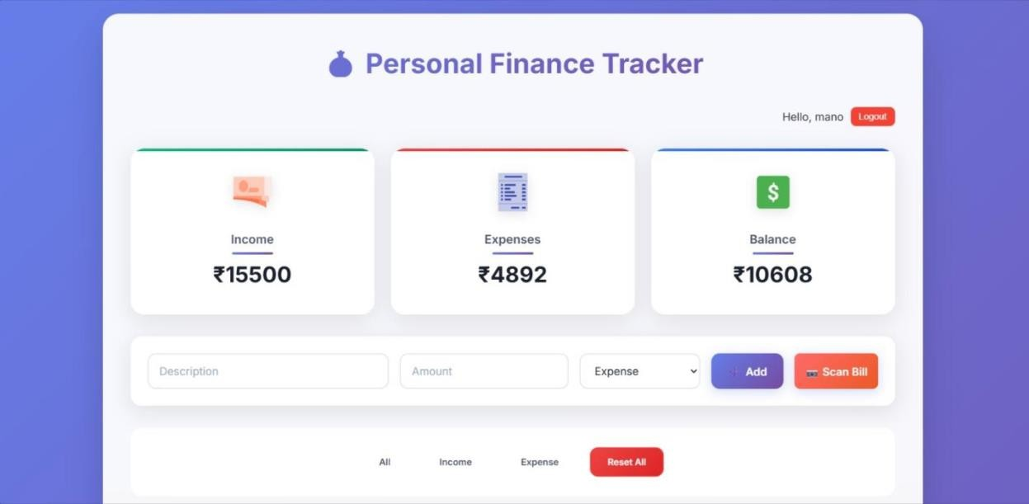

Fig B.1: Personal Finance Tracker Dashboard and User Interface

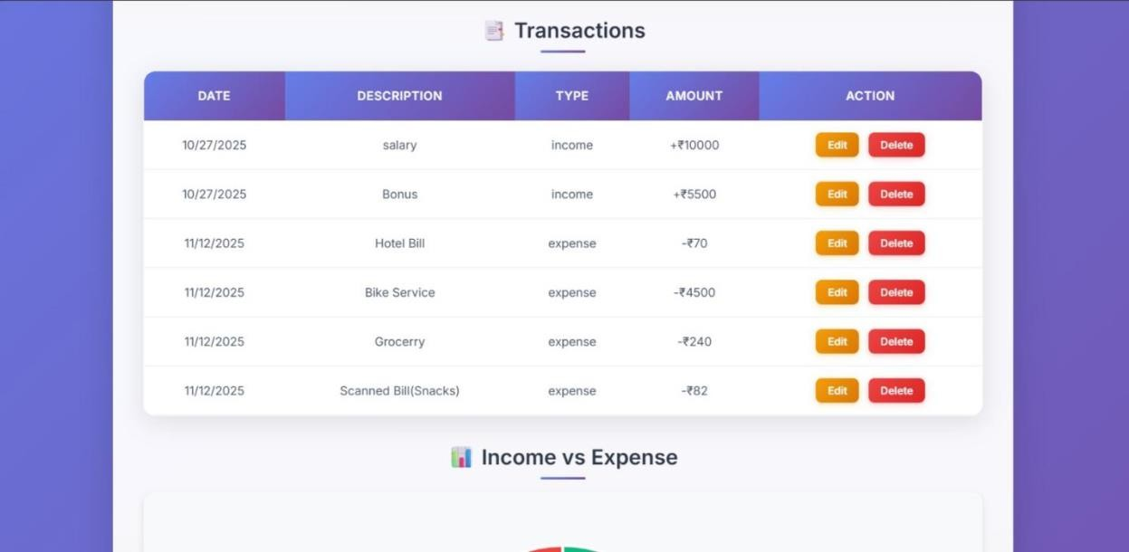

Fig B.2: Transaction History Interface

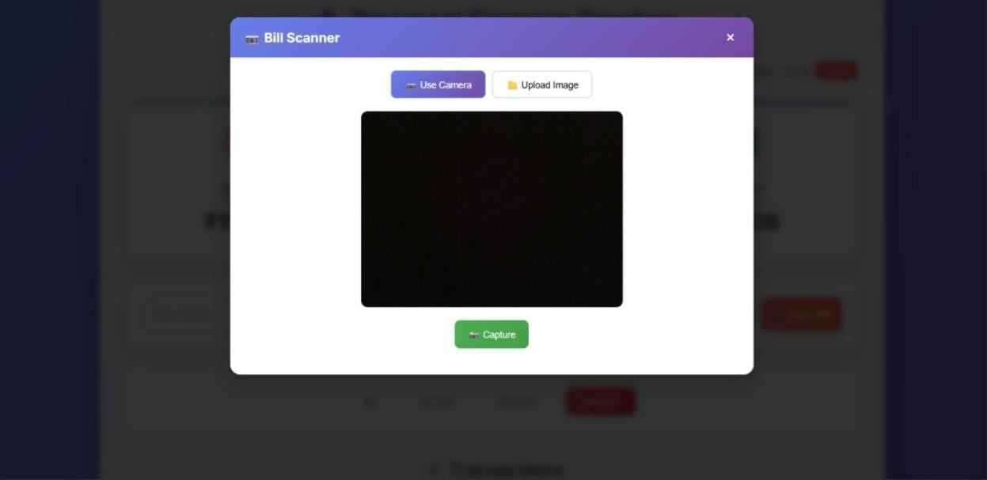

Fig B.3: Bill Scanner Interface

